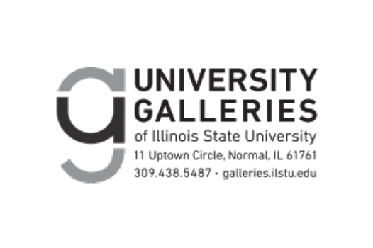

University Galleries of Illinois State University is pleased to present the 2026 Faculty Biennial from October 14 through December 12, 2026. All events are free and open to the public.
Organized every two years, the Faculty Biennial presents new and recent research by faculty in the Wonsook Kim School of Art and Design and the School of Creative Technologies. The artists participating in the exhibition represent the areas of Art History, Art Teacher Education, Creative Technologies, Graphic Design, and Studio Art.
2026 Faculty Biennial participants: Tim Abel, Ladan Bahmani, Jason Dunda, Simone Downie, Andreas Fischer, Brian Franklin, Colby Jennings, Melissa Johnson, Katie Krcmarik, Christopher Lackey, Rose Marshack, Melissa Oresky, Morgan Price, Jason Reblando, Nathania Rubin, Tanya Scott, Archana Shekara, Sarah Smelser, Bert Stabler (with Mo Fizdale), Albion Stafford, Annie Sungkajun, Rick Valentin, and Michael Wille.
This exhibition is the focus of multiple educational programs. Faculty members will lead workshops, a lecture, and a demonstration, as well as perform a concert. University Galleries’ staff will lead art-making and writing workshops for ISU students, families, and K-12 students. Free curator-led tours are available by appointment for the duration of the exhibition.

Events and programming
All events are free and open to the public.

- Wednesday, October 14, from 4:00 to 5:30 p.m.
Opening reception

- Friday, October 16, from noon to 1:00 p.m.
Independent drawing hour: Spend time looking closely at artworks in the exhibition and drawing at your own pace. Materials provided.

- Wednesday, October 21 at noon
Lecture: “’giving movement to the surrounding language:’ Woolf Words/Tactile Investigations” by Melissa Johnson (professor, art history and visual culture)

- Tuesday, October 27, from 3:00 to 5:00 p.m.
Workshop: Secret Painting Club organized by Jason Dunda (assistant professor, 2D Foundations)
and Andreas Fischer (associate professor, painting and drawing). For this art-making event,
participants will socialize while working on their own projects. Participants may bring their own
materials or use the provided materials. This event is an extension of Dunda and Fischer’s weekly
drawing meetings, which they call “Secret Painting Club.” The artists say, “All are welcome, so
be sure to tell everyone about this top-secret gathering.” Registration required.

- Saturday, October 31, from 1:00 to 3:30 p.m.
Workshop: Fabric doll-making led by Morgan Price (associate professor, printmaking). All
materials and instruction provided. Registration required.

- Friday, November 6, from noon to 1:00 p.m.
Poetry hour: Drop in and spend time writing poetry in response to artworks on view. Materials provided, including poetry templates.

- Sunday, November 8, from noon to 3:30 p.m.
Workshop: Custom warp tapestry weavings led by Tanya Scott (curator of education). All materials and instruction provided. Registration required.

- Wednesday, November 11, from 1:00 to 5:00 p.m.
Demonstration: Human-computer interaction projects led by Christopher Lackey (assistant professor, creative technologies). Drop by any time between 1:00 and 5:00 p.m. while Lackey demonstrates the use of camera-based tracking, microcontroller/sensor inputs, and mobile-based controllers.

- Friday, November 13, from 6:00 to 7:00 p.m.
Performance: Salaryman (featuring Rick Valentin, professor, creative technologies; Rose Marshack, professor, creative technologies; Jim Valentin; and Howie Kantoff). The band’s “unique blend of instrumental electronic rock,” in their words, “fuses the obsolete with the emergent, embracing the friction between technological optimism and late-stage capitalist decline.”

- Saturday, November 14, from 11:00 a.m. to noon
Sensory-friendly hour: Visit the exhibition before opening hours to enjoy dimmed lighting and a quiet space.

- Saturday, November 14, from 1:00 to 2:30 p.m.
Workshop: Following a brief tour of the Faculty Biennial, participants will make a project inspired by the works on view. Materials and instruction provided by University Galleries’ staff. Registration required.

- Field trip program, curator-led tours, and workshops are available by appointment throughout the exhibition. Reimbursements are available for K-12 schools or community organizations to offset the costs of transportation. Please contact University Galleries at Gallery@IllinoisState.edu or (309) 438-5487 to schedule an appointment.

University Galleries, a unit in the Wonsook Kim College of Fine Arts, is located at 11 Uptown Circle, Suite 103, at the corner of Beaufort and Broadway streets. Parking is available in the Uptown Station parking deck located directly above University Galleries—the first hour is free, as well as any time after 5:01 p.m.

You can find University Galleries on Facebook, Instagram, and X, and sign up to receive email updates through the newsletter. Please contact gallery@IllinoisState.edu or call (309) 438-5487 if you need to arrange an accommodation to participate in any events related to these exhibitions.

